**Department of Computer Science and Engineering**

|  |  |
| --- | --- |
| **Course Code:CSE221** | **Credits: 1.5** |
| **Course Name: Algorithms** | **Semester: Fall’18** |

**Lab 08  
All Pairs Shortest Path**

**(Floyd Warshall)**

1. **Topic Overview:**

The idea of all pairs shortest path algorithm is to find the shortest path from any node to all/any other node in a connected **weighted** graph. The shortest path scenario is something we encounter every day when we set out from home on our way to university and there are multiple routes. The weights might be considered as traffic level, distance or monetary cost. The path with the minimum total traffic, total distance or total cost will be extracted using a shortest path algorithm.

Sometimes, we might not be concerned with a specific source and destination. Instead, we might want to find all shortest paths between any two nodes in a graph/network. In such cases, we can use the Floyd Warshall algorithm, which is a dynamic programming solution to find the shortest path in a connected weighted graph for all pairs of nodes. The time complexity of Floyd Warshall is O($V^{3}$), where V is the number of nodes.

1. **Lesson Fit:**

To solve this problem, the students must have a basic idea on the following concepts:

* 1. Graph Representation and Computation
  2. Optimization Task

1. **Learning Outcome:**

After this lab, the students will be able to:

* 1. Find shortest path from a connected graph for all pairs of nodes
  2. Represent real life problem in graphs
  3. Optimize the calculation for finding solution

1. **Acceptance and Evaluation**

Students will show their progress as they complete each problem. They will be marked according to their class performance. There maybe students who might not be able to finish all the tasks, they will submit them later and give a viva to get their performance mark. The mark distribution for the lab will be as follows:

Code: 05

Viva: 05

1. **Activity Detail**
   1. **First 1.5 hours  
      Explanation:**The lab instructor will explain how to represent a connected graph in a matrix and traversing the graph using the matrix. Instructor will explain the Floyd Warshall algorithm in a connected graph and will let the students understand the approach thoroughly.
   2. **Second 1.5 hours**

**Implementation:**

After explanation, the students will implement Floyd Warshall algorithm to solve a given problem.

**Problem Task: See Activity**

1. **Home tasks:** Unfinished tasks

**Lab 8 Activity**

Suppose BRACU organizes a treasure hunt for the students. Each department from the University will send a team of 5 students to participate in the hunt. The winning team will earn a paid trip to Saint Martin’s Island for the entire department, teachers and students included. At the day of the hunt, the teams received a map of the mohakhali area, with the “points of interest” circled in red. They were given 30 minutes to strategize and were told after 30 minutes all teams will be given different randomly selected starting locations. Depending on their starting location, they will find a clue that will take them to another location (or point of interest), where they will find the next clue. Eventually, they will reach the “heart of martin” which contains the prize. The first team to reach the “heart of martin” will win the hunt and thus the trip.

Now, you are one of the members of the CSE team. You come up with a brilliant plan during the 30 minute strategy period. Since you do not know your starting location, the end location or the intermediate locations, you decide to find a way to minimize the time to travel between any two “points of interest”. So, you go to google maps and check the distance between all points and find the quickest path between all “points of interest” using the Floyd-Warshall shortest path algorithm. The map and the algorithm are given below. The weight on the map shows the distance between each point. Now, whatever the starting point or intermediate points, you will be able to use the shortest paths you have found and save time on travelling between points. Thus, thanks to your brilliant mind, your team has a slight advantage over the other teams as they do not know this algorithm and you might just help your department win that amazing trip.

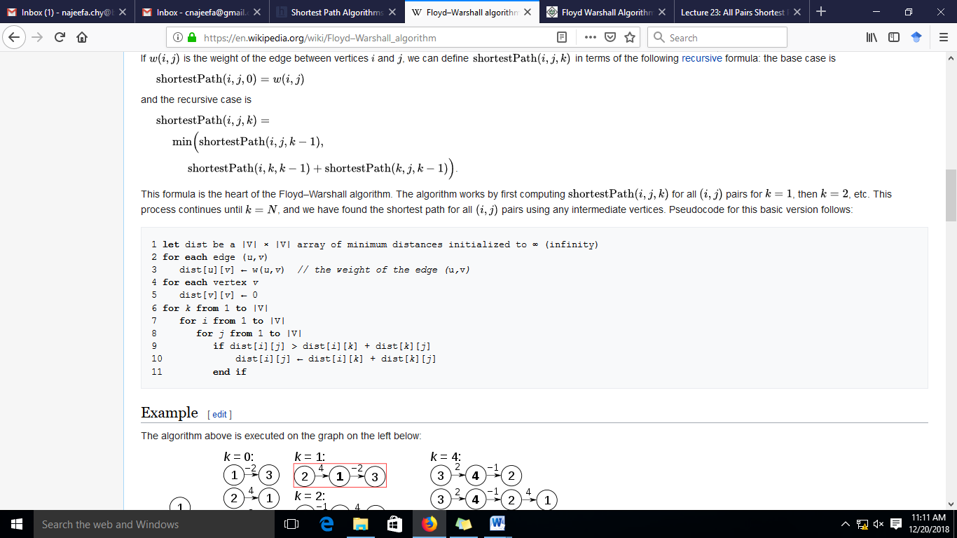

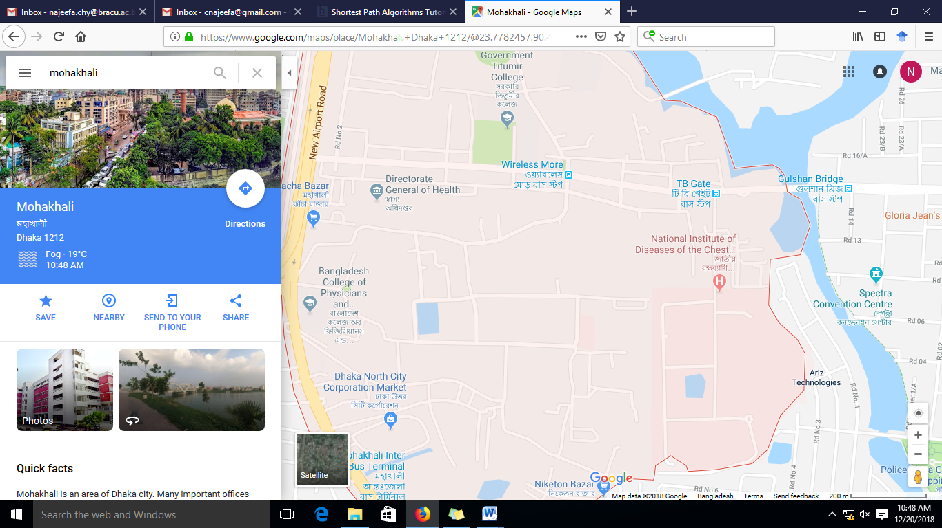

**90**

**K**

**J**

**H**

**I**

**G**

**F**

**E**

**D**

**B**

**C**

**A**

**17**

**5**

**7**

**25**

**18**

**5**

**8**

**10**

**10**

**35**

**20**

**25**

**35**

ICDDR

Brac

University

**Input Format:**

First line should be “n m”, where n is the number of nodes and m is the number of edges. Then next “m” lines will contains “u v weight” (e.g. A B 7)

**Output Format:**

Output the shortest distance between all nodes.

A B C …….

A 0 7 25

B ………………….

C ………………….